**Proj2Advisors Before Changes**

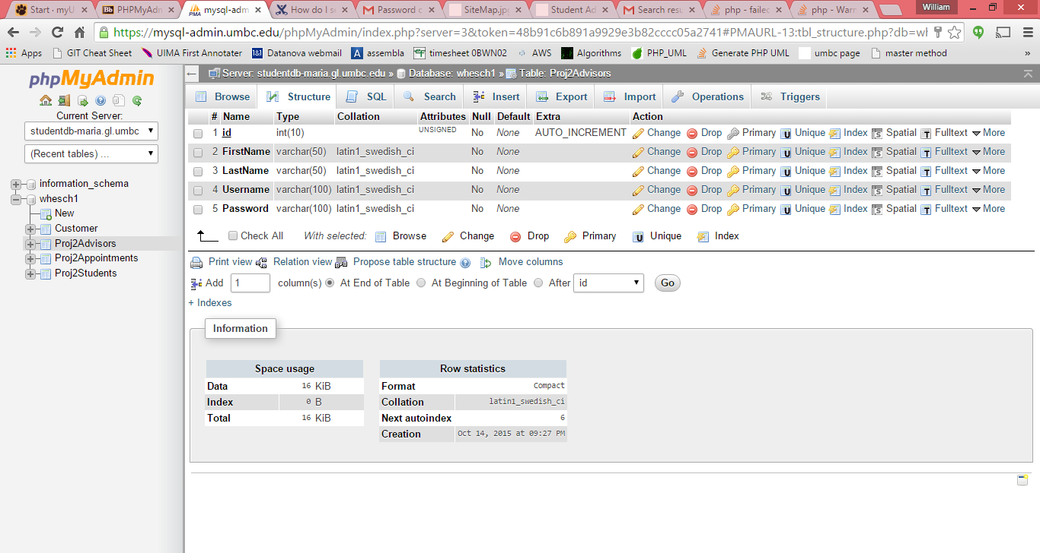

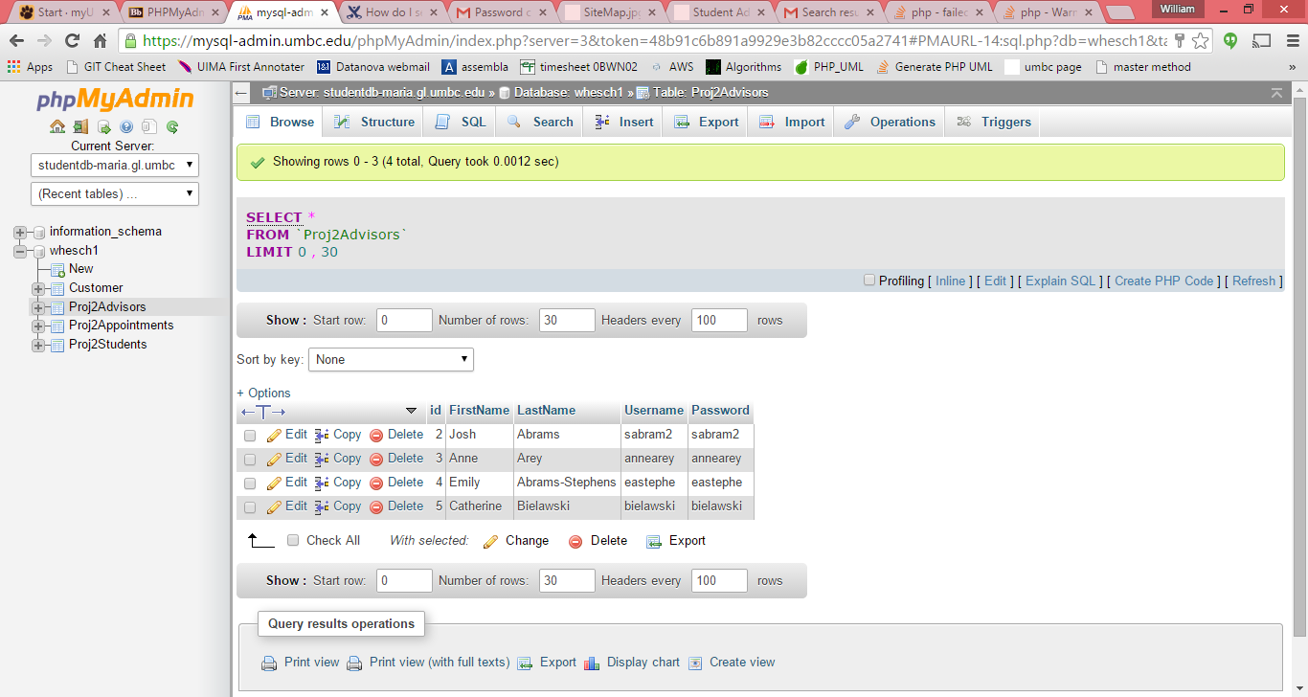

**Proj2Advisors After Changes**

Overall Challenges : The primary challenge that I had in adjusting the advisors table to accommodate the room number was finding out all the locations in the PHP code where the room number was referenced. Adding the column was rather trivial, but pouring over countless lines of php looking for all instances where the advisor was referenced, took time. In the end, I was able to display the advisor’s room number in all appropriate locations.

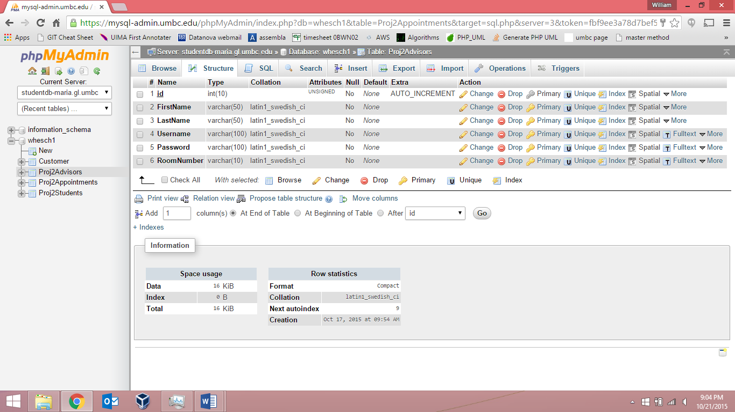

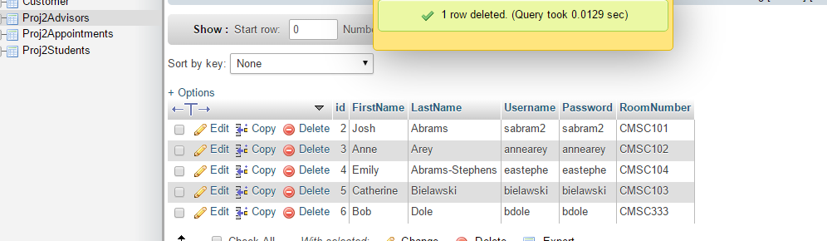

**Proj2Appointments Before Changes**

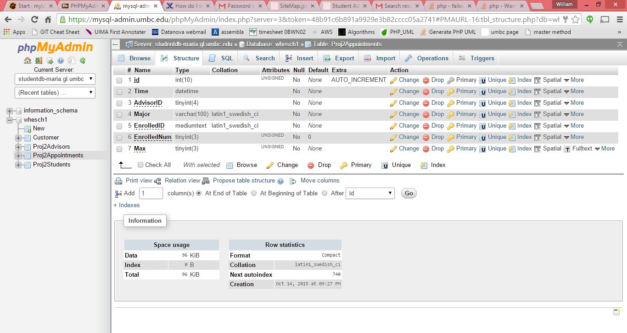

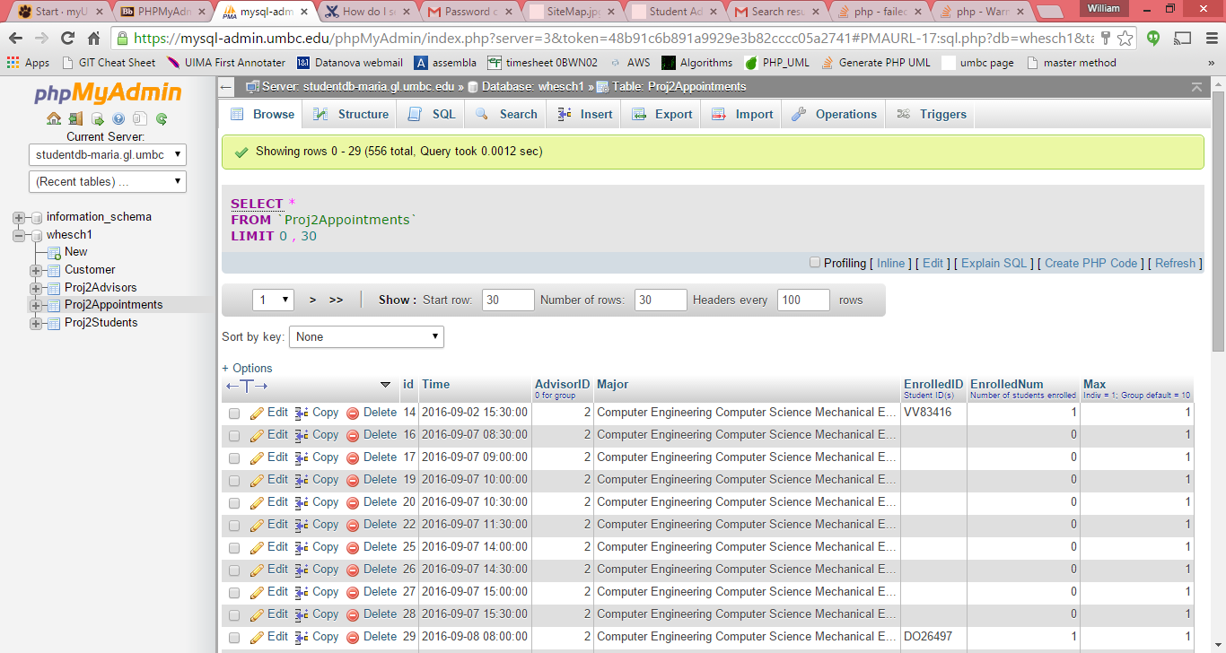

**Proj2Appointments After Changes**

Overall Challenges : The primary challenge that I had in adjusting the appointments table to accommodate the abbreviated majors list was finding out all the locations in the PHP code where the major was referenced. Each time, I thought I had the data pulling correctly, I would check the database and find that I forgot to abbreviate an insert somewhere!!

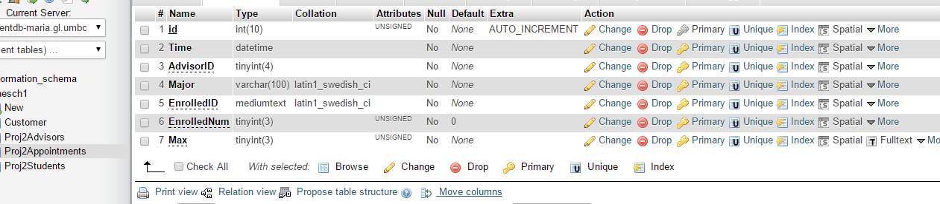

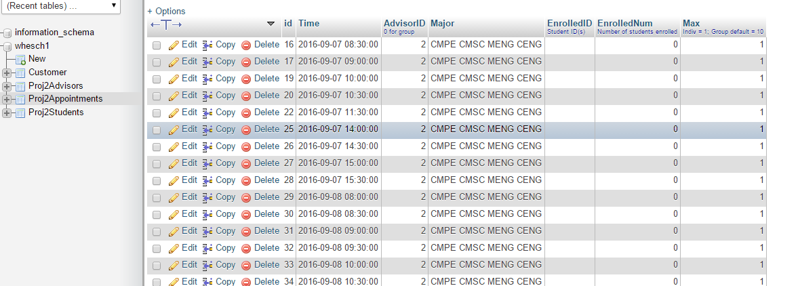

**Proj2Students Before Changes**

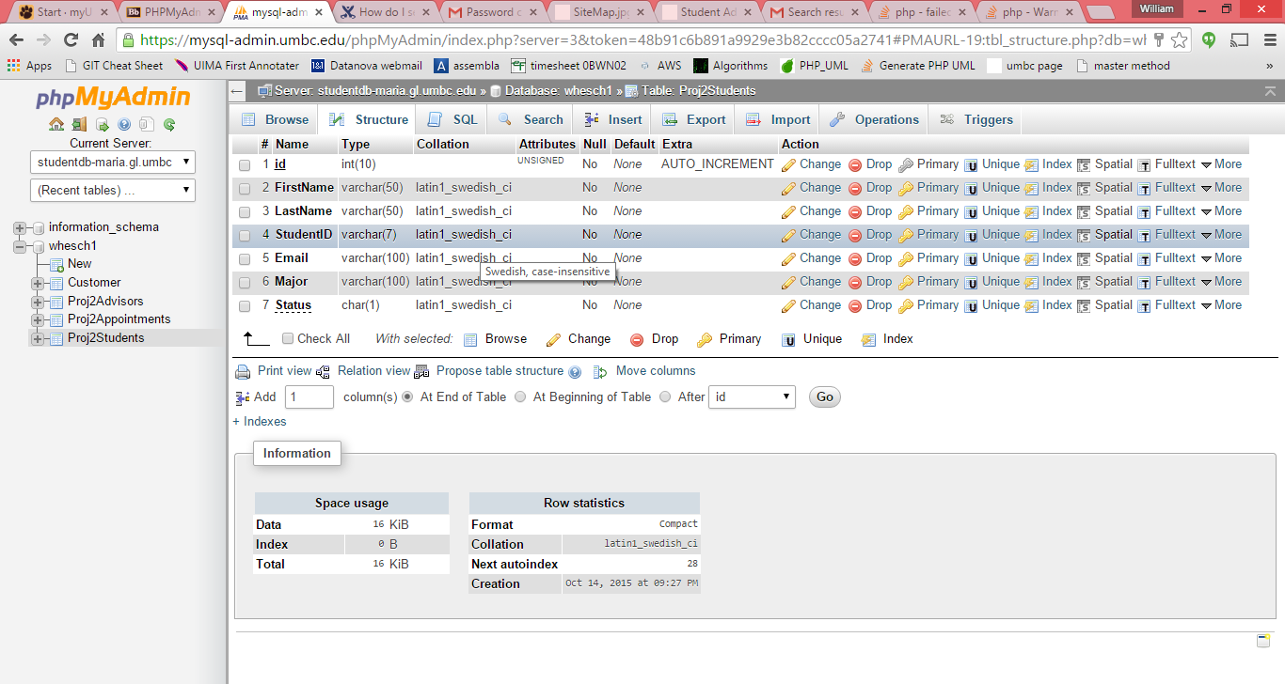

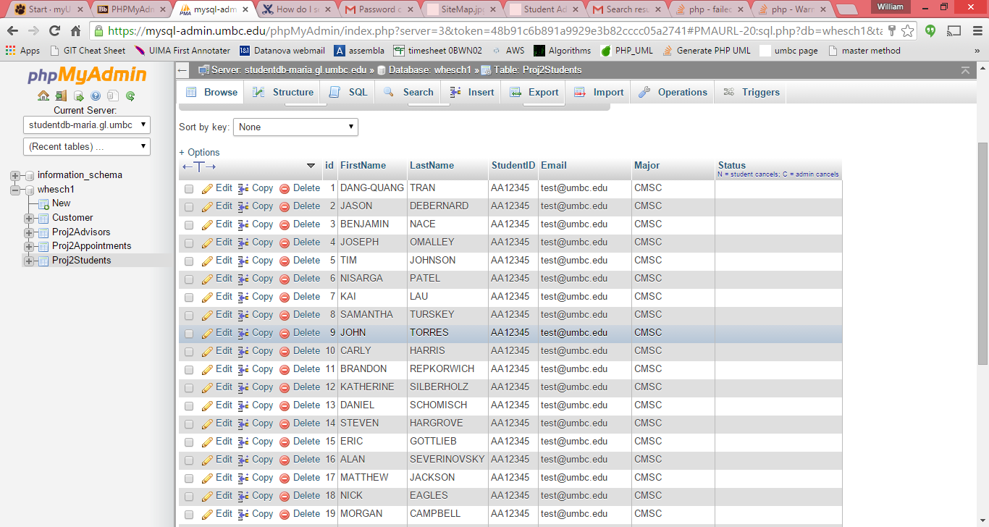

**Proj2Students After Changes**

Overall Challenges : The primary challenge that I had in adjusting the students table to accommodate the abbreviated student major was finding out all the locations in the PHP code where the data was selected/inserted. I initially forgot that appointments needed to abbreviated as well, but when I saw that the data was being joined, I realized I needed to make the change there too.

